**VCS Task**

**Task Description:**

Establish a new directory, populate it with script files, initiate an empty repository on GitHub, convert the local directory into a Git repository, and link it to GitHub for pushing the code into the repository.Perform merge, rebase, stash commands in following github repo.

Establish a new directory

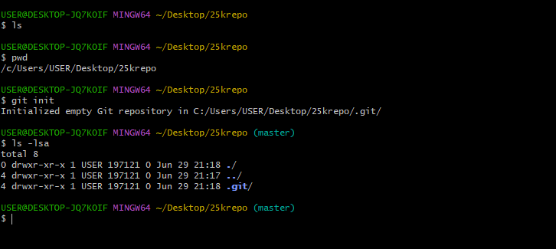

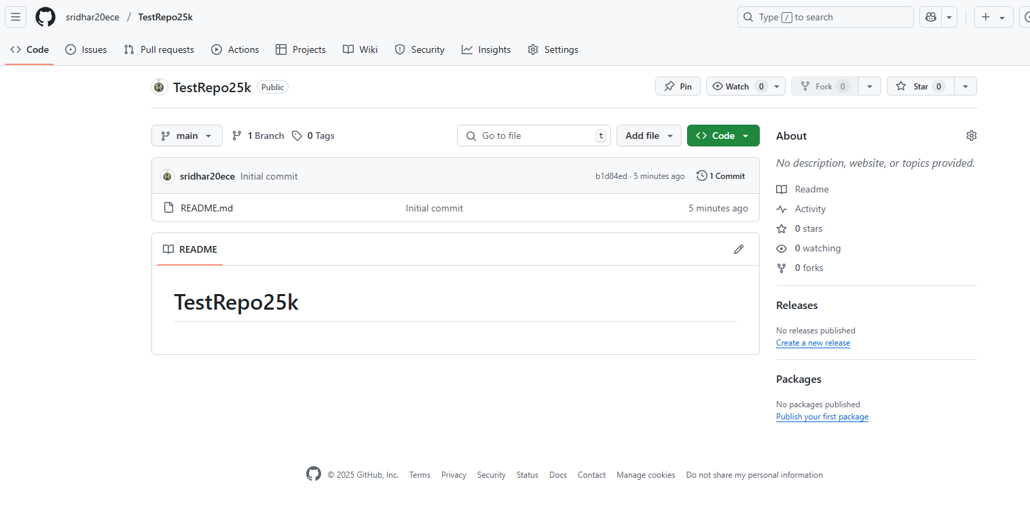  
**Git Rebase: -**  
  
  
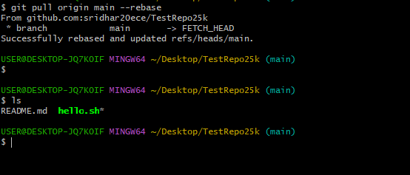  
 **Git PUSH:**  
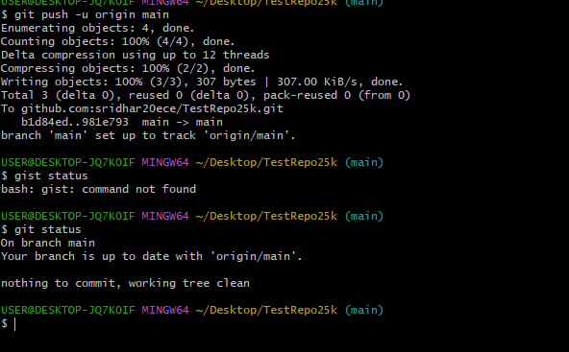  
  
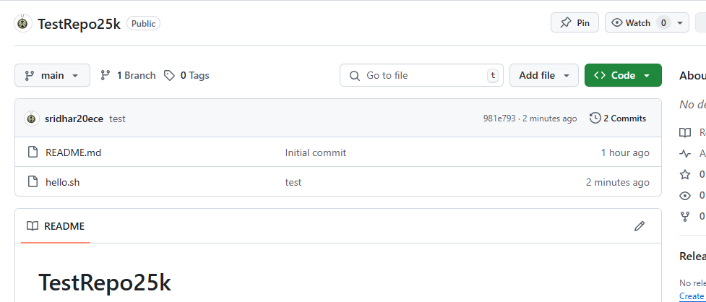  
  
  
**GIT STASH: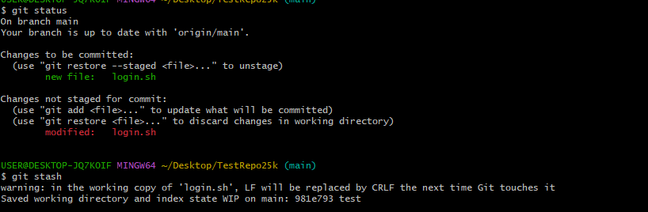 Merge:**

